## Supplementary file 2. the step-by-step guidance for Case study 2-1

The selected metabolites: 138 unique differentially abundant metabolomic features (case2-1/138metabolites.txt).

Step i) Select module. Open the web page, enter the search page (a) and select “Batch analysis of multiple metabolites” module (b).

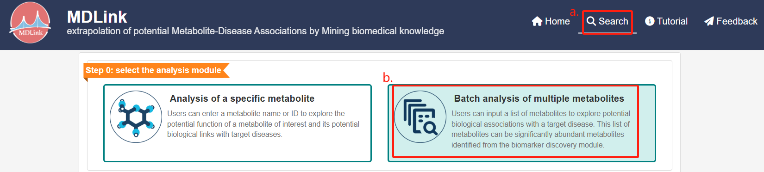

Step ii) Input multiple metabolites.

(a) choose input name or IDS of metabolites,

(b) input the names of metabolites

(c) click “Search”.

Uploading a plain text file containing metabolite names or IDs is also acceptable.

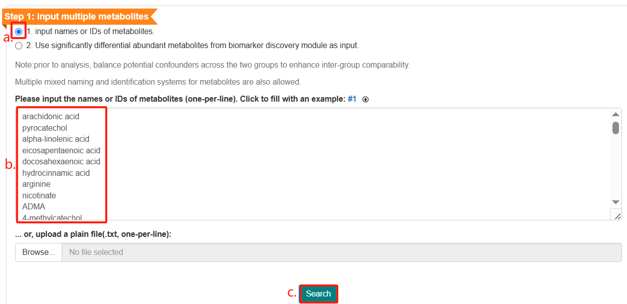

A brief summary for these metabolites will be shown.

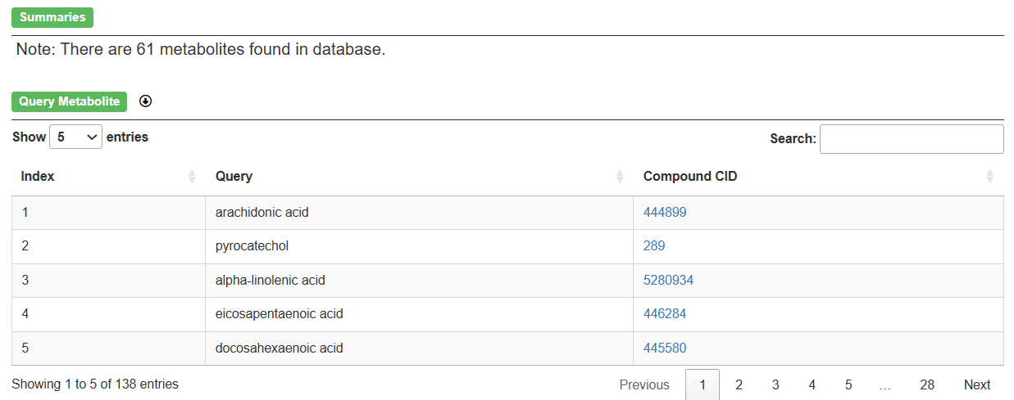

Step iii) Input the target disease.

(a) choose “1. input the name or DOID of the disease”,

(b) input Crohn’s disease,

(c) click “Search”.

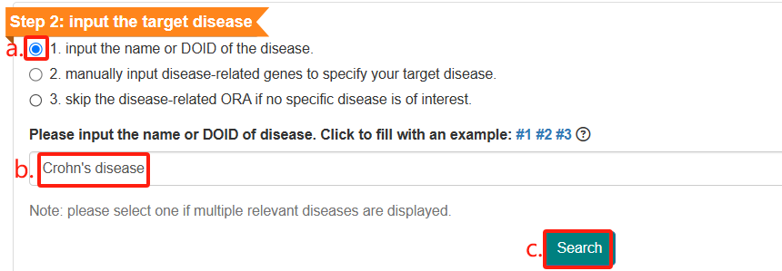

The queried disease and disease-related genes will be presented.

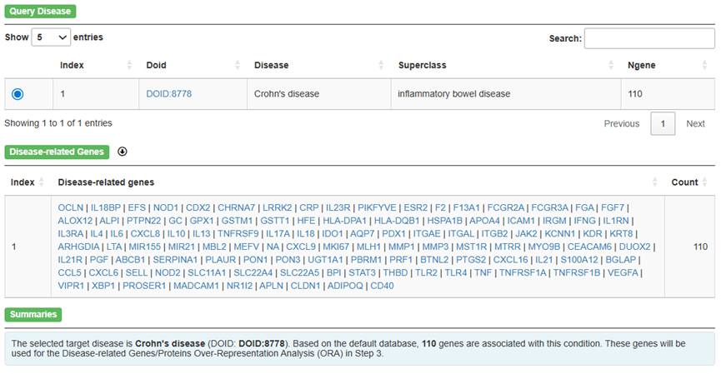

Step iv) Set parameters for three branches.

(a) select “high confidence (score >= 0.7)” as the minimum confidence score for retrieving target proteins.

(b) choose the option “2. Input the result of WGCNA manually, including metabolites and modules”,

(c) browse to upload the corresponding file (case2-1/IBD_CDvsCtrl_WGCNA_Modules.tsv).

(d) set the minimum confidence score for potential interaction proteins/genes to “high confidence (score >= 0.7)”,

(e) click “Search” to proceed with the analysis.

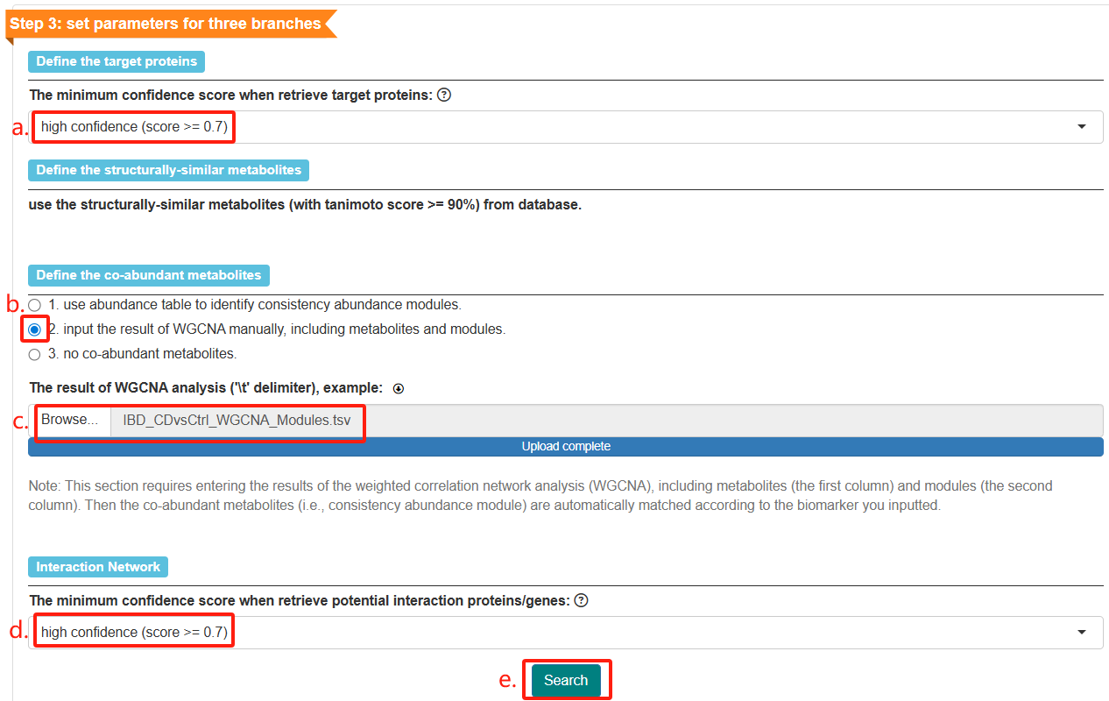

The co-abundant metabolites (i.e., consistency abundance module) and disease-related genes/proteins ORA results will be displayed.

